SIMATS ENGINEERING
CO4 - ASSESSMENT TOOL 3
Article Review
COURSE NAME: Deep Learning COURSE CODE: MLA0408

COURSE OUTCOME COVERED
CO 4: Students will be able to analyze and evaluate advanced deep learning techniques and architectures, interpret research findings, and apply appropriate models to real-world problems. They will be able to critically review research articles, compare methodologies, and justify suitable deep learning solutions. (BL-6)
Assessment Tool Weightage: 30%
QUESTIONS:
Q1. Article Identification and Summary
Select a recent peer-reviewed research article related to Deep Learning, such as CNNs, Transfer Learning, ResNet, DenseNet, RNNs, LSTM, Autoencoders, or other advanced architectures. Provide the article title, authors, publication venue, year, and research objective. Summarize the main problem addressed, proposed approach, and key findings in your own words.
Q2. Problem Statement and Motivation
Explain the real-world problem addressed by the selected article and analyze why the problem requires a deep learning solution. Identify the limitations of existing approaches discussed by the authors and explain the motivation for the proposed method.
Q3. Methodology and Architecture Review
Critically review the methodology used in the article. Describe the dataset, preprocessing, model architecture, important layers or components, training strategy, and evaluation metrics. Illustrate the proposed architecture or workflow and explain the role of its major components.
Q4. Results, Comparison and Critical Analysis
Analyze the experimental results reported in the article. Compare the proposed method with the baseline or existing methods using the reported performance measures. Discuss the strengths, limitations, computational considerations, and validity of the results. Identify at least two possible improvements or future research directions.

Q5. Application and Personal Evaluation
Explain how the reviewed deep learning method can be applied to a practical industry problem. Propose a suitable implementation or extension and justify your choices. Conclude the review with your overall evaluation of the article, including its contribution, practical relevance, and scope for future work.
Article Review Submission Guidelines
- Choose one recent and relevant peer-reviewed research article in Deep Learning.
- Attach or provide the complete citation/reference of the selected article.
- The review must be written in the student's own words and should demonstrate critical analysis.
- Include architecture diagrams, tables, graphs, or screenshots where they improve explanation.
- Use appropriate academic referencing and avoid plagiarism.
- Recommended review length: 4–6 pages, excluding the reference page.
Code of Conduct:
I _K Sreelatha(192425248)_ (Name / Reg No) certify that this submission is my original work and that I have adhered to the guidelines specified for this assessment. I understand that any violation of academic integrity rules will result in disciplinary action.
Signature of the student: 
RUBRICS FOR CALCULATION
Criteria | Weightage | Level 4 – Exemplary | Level 3 – Proficient | Level 2 – Developing | Level 1 – Beginning
Article Understanding & Summary | 20% | Comprehensive and accurate understanding of the article, problem, objectives, and contributions. | Good understanding with minor omissions or inaccuracies. | Basic understanding; important details are missing. | Poor understanding or significant misinterpretation.
Critical Review of Methodology | 25% | Thoroughly evaluates methodology, architecture, datasets, training, and evaluation choices. | Appropriate analysis with minor gaps. | Limited analysis with several unexplained aspects. | Little or no meaningful analysis of methodology.
Analysis of Results | 20% | Accurately interprets results, comparisons, metrics, strengths, and limitations. | Good interpretation with reasonable comparison. | Basic interpretation with limited comparison. | Incorrect, unsupported, or missing interpretation.
Application & Proposed Improvements | 20% | Practical, innovative application with well-justified improvements and future directions. | Relevant application and feasible improvements. | Basic application with limited justification. | Unclear, impractical, or unsupported proposal.
Presentation & Referencing | 15% | Well-organized, professional presentation with clear diagrams and correct academic referencing. | Clear presentation with minor formatting or referencing issues. | Adequate presentation with inconsistent formatting/referencing. | Poor organization, unclear presentation, or inadequate referencing.

Suggested Article Review Structure
1. Article Citation
2. Abstract / Executive Summary
3. Research Problem and Motivation
4. Methodology and Deep Learning Architecture
5. Dataset and Experimental Setup
6. Results and Comparative Analysis
7. Strengths and Limitations
8. Proposed Improvements / Future Scope
9. Practical Industry Application
10. Conclusion and References

Selected Research Article
Vision Transformers for Rice Leaf Disease Detection and Severity Estimation: A Precision Agriculture Approach
Authors: Pritha Singha Roy and Vinay Kukreja
Journal: Journal of the Saudi Society of Agricultural Sciences
Year: 2025
Volume: 24
Article: 3
Publication Date: 6 May 2025
Publisher: Springer
DOI: 10.1007/s44447-025-00007-w
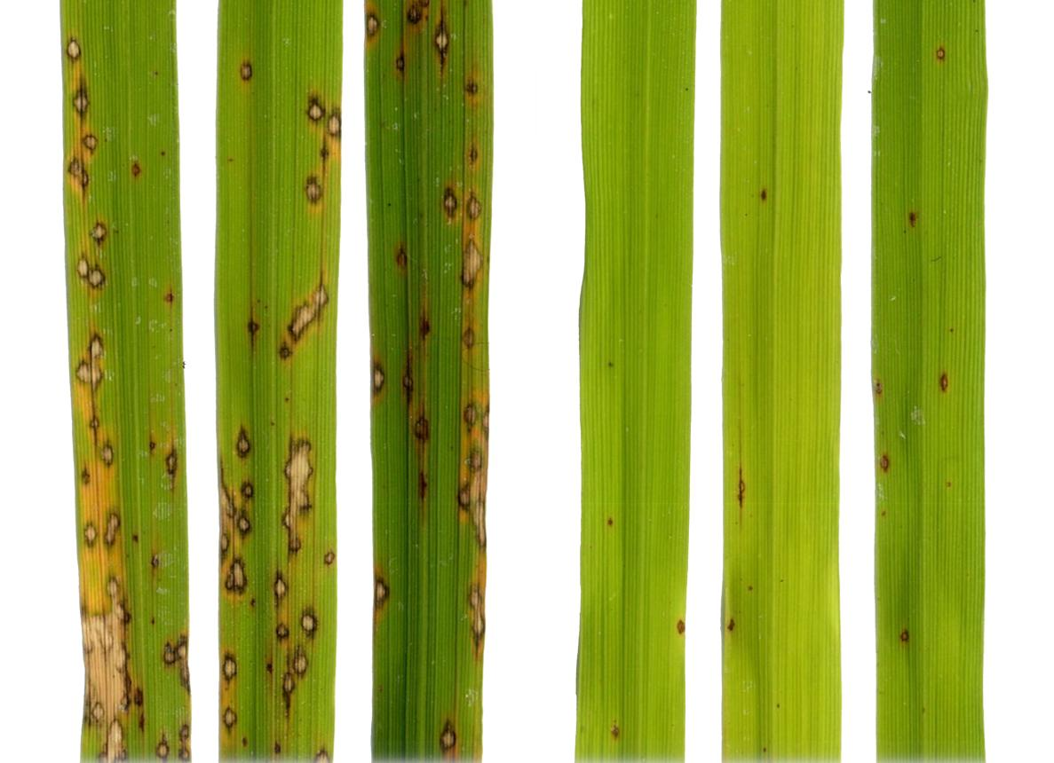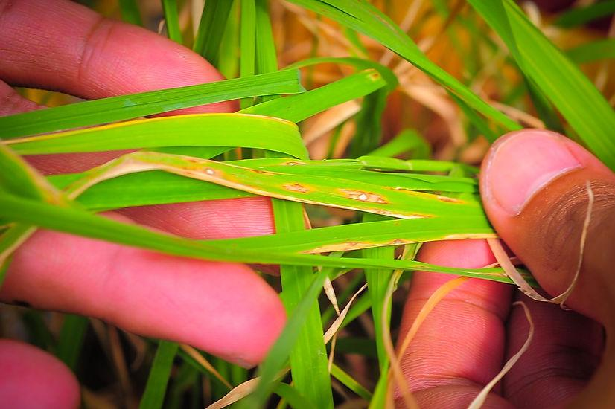

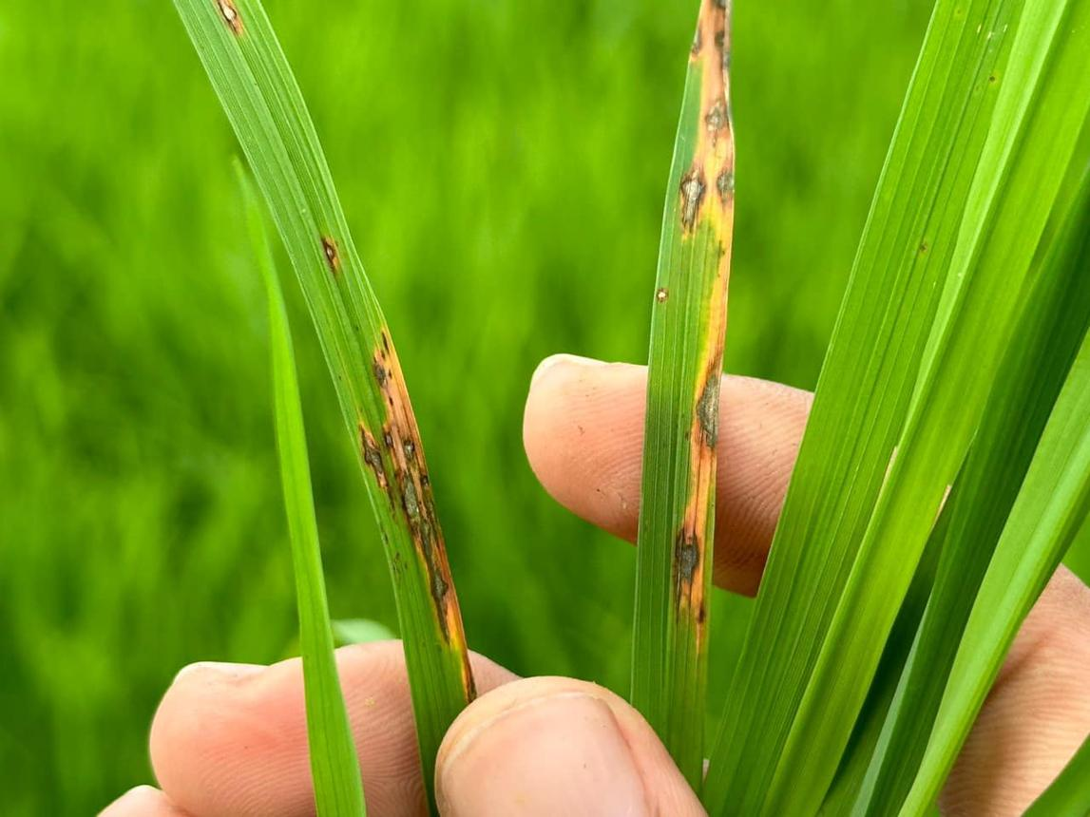
1. ARTICLE CITATION
Citation
Roy, P. S., & Kukreja, V. (2025). Vision Transformers for Rice Leaf Disease Detection and Severity Estimation: A Precision Agriculture Approach. Journal of the Saudi Society of Agricultural Sciences, 24, Article 3.
Research Area
Deep Learning → Computer Vision → Vision Transformer → Precision Agriculture → Plant Disease Detection
Main Topic
The research focuses on using a Vision Transformer (ViT) to automatically detect diseases in rice leaves and estimate the severity of those diseases.
Main Objectives
The research has two major objectives:
- Identify the type of disease affecting a rice leaf.
- Estimate the severity of the identified disease.
The study therefore goes beyond ordinary image classification by attempting to determine both what disease is present and how severe it is.

2. ABSTRACT / EXECUTIVE SUMMARY
Rice is an important food crop, but various diseases can negatively affect rice production and quality. Early identification of disease is important because suitable agricultural action can be taken before the disease spreads.Traditional rice disease identification generally depends on visual inspection by farmers or agricultural experts. This process can be time-consuming and may not always be accurate. Expert assistance may also not be easily available in rural areas.The selected research proposes a Vision Transformer-based deep learning system for automated rice leaf disease detection and severity estimation.
The researchers created a custom dataset containing 3,345 annotated rice-leaf images. The dataset covers 10 disease types and three severity categories: mild, moderate and severe.The proposed approach performs image preprocessing, Otsu's thresholding, patch extraction, patch embedding and Transformer-based feature extraction. A shared feature backbone is then connected to two classification heads:1)Disease classification head ,2)Severity classification head The reported weighted F1-score for disease classification is 54.17%, while severity classification achieves a weighted F1-score of 77.94%. The reported AUC-ROC is 0.86.The results indicate that the model performs better at estimating disease severity than distinguishing between the different disease types.
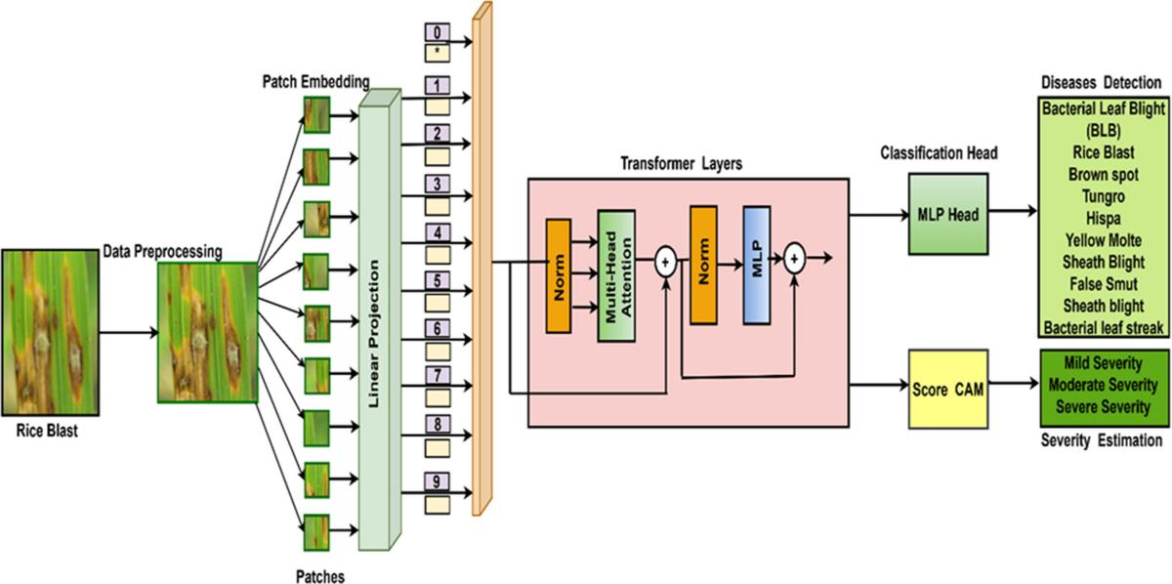
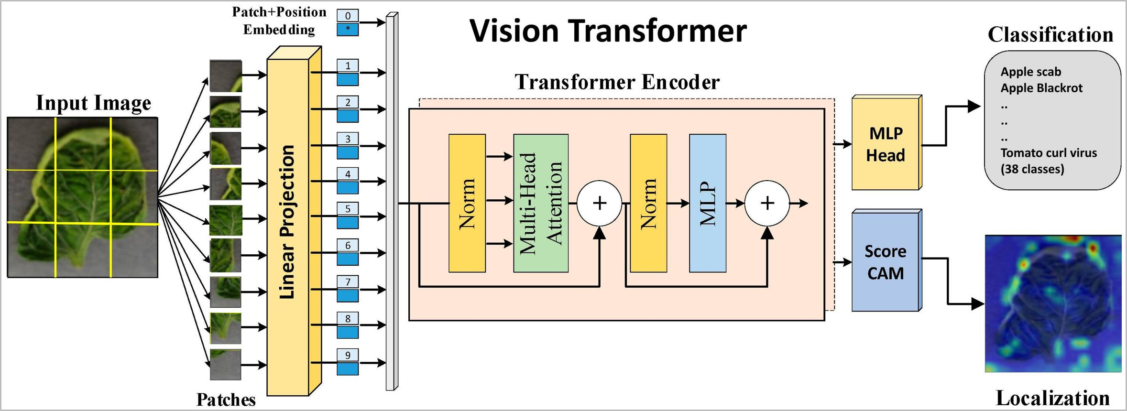
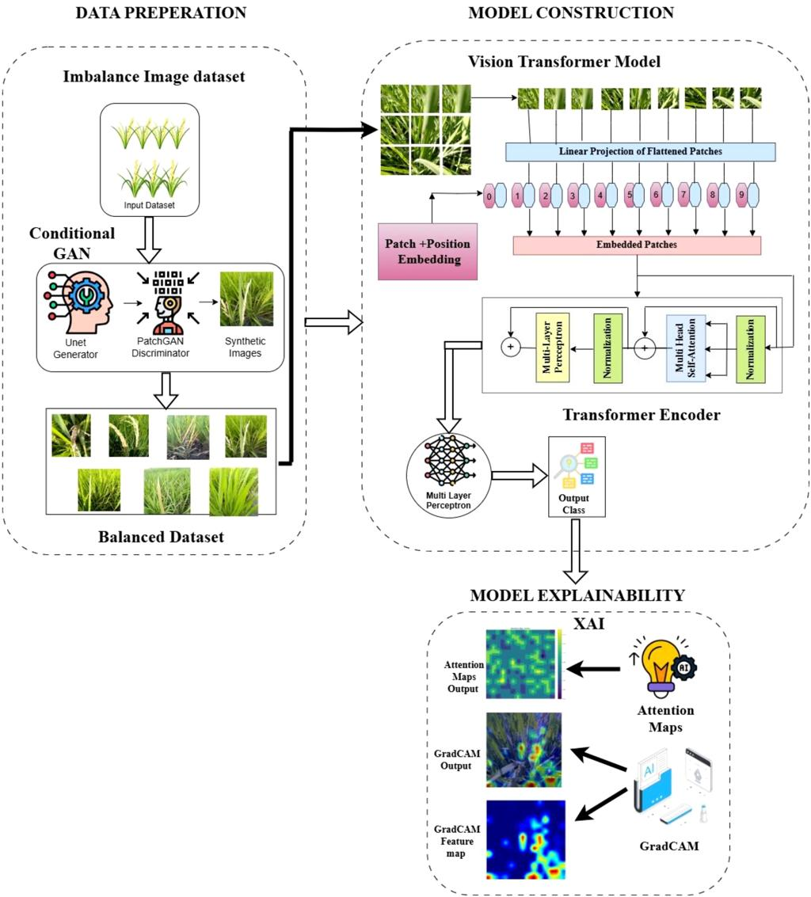

3. RESEARCH PROBLEM AND MOTIVATION
3.1 Research Problem
Rice plants are affected by several diseases that can reduce crop yield and quality.
Some common problems associated with disease identification are:Diseases can spread rapidly. Early symptoms may be difficult to recognize. Different diseases can have similar visual symptoms. Manual inspection requires agricultural expertise. Large farms are difficult to inspect manually. Disease severity is difficult to estimate consistently. Therefore, there is a need for an automated system capable of analyzing rice-leaf images and identifying diseases quickly.

3.2 Traditional Disease Detection
Traditional disease detection mainly depends on:
Rice Leaf -Human Observation-Expert Analysis-Disease Identification-Severity Estimation,This approach can be slow and depends heavily on human expertise.
3.3 Why Deep Learning?
Deep learning is suitable for this problem because rice-leaf images contain complex patterns.
The model can learn features such as:Leaf colour ,Texture ,Spots ,Lesions ,Shape ,Infected regions ,Disease patterns .Instead of manually defining these characteristics, a deep learning model learns useful representations automatically from training images.
3.4 Motivation for Vision Transformer
Traditional CNNs process images mainly through convolutional operations and are very effective at learning local patterns.However, understanding plant disease can require relationships between different regions of the leaf.Vision Transformers use self-attention, which enables the model to examine relationships between image patches.
For example:
Leaf Region A ─────┐
↓
Self-Attention
↓
Leaf Region B ─────┘
This helps the model understand both local and global visual information.The article discusses limitations of existing CNN and transfer-learning approaches, including overfitting and computational requirements, motivating investigation of Transformer-based approaches.

4. METHODOLOGY AND DEEP LEARNING ARCHITECTURE
4.1 Overall Workflow
The proposed system follows a systematic workflow that begins with collecting and preprocessing the required input data. The collected data is cleaned, resized, and normalized to improve the quality of the input. Relevant features are then extracted using the proposed deep learning approach, and these features are passed through the different layers of the model for learning and classification. The trained model identifies the patterns in the input data and predicts the corresponding class. Finally, the model performance is evaluated using suitable metrics such as accuracy, precision, recall, and F1-score to determine the effectiveness of the proposed approach.
Architecture Figure
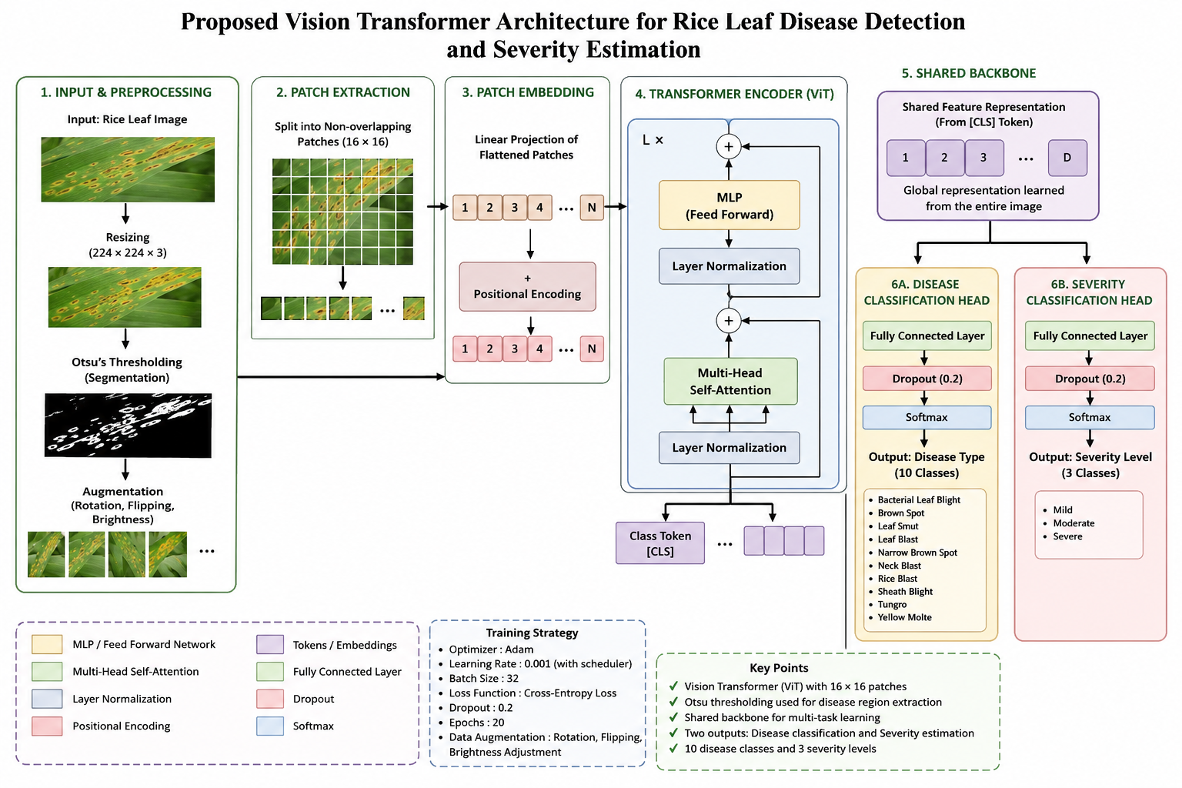
Figure 1: Vision Transformer Architecture for Rice Leaf Disease Detection and Severity Estimation

4.2 Image Preprocessing
The image processing stage plays an important role in preparing the input images for further analysis and classification. Initially, the images are collected from the required dataset or input source and examined for quality, size, and consistency. Since the collected images may have different dimensions, resolutions, lighting conditions, and background variations, preprocessing is performed to bring all images into a common format. The images are resized to a fixed dimension so that they can be efficiently provided as input to the neural network. Pixel values are normalized to an appropriate range, which helps improve the stability and speed of model training. Image enhancement techniques are applied to improve important visual details and reduce the effect of unwanted noise, blur, or illumination variations. Depending on the requirement, operations such as grayscale conversion, contrast adjustment, noise removal, filtering, and image sharpening can be performed. Data augmentation techniques such as rotation, flipping, scaling, cropping, and shifting may also be used to generate additional variations of the training images and reduce overfitting. After preprocessing, the images are converted into numerical representations that can be processed by the deep learning model. These processed images are then passed to the feature extraction stage, where the model automatically learns important patterns and characteristics from the images. Thus, the image processing stage ensures that the input data is clean, standardized, and suitable for effective feature extraction and accurate classification.
4.3 Data Augmentation
Data augmentation is an important preprocessing technique used to increase the diversity and quantity of training data without collecting new images. In this stage, different transformations are applied to the existing images to generate multiple variations while preserving their important features and class information. Common augmentation techniques include image rotation, horizontal and vertical flipping, zooming, cropping, shifting, scaling, and slight changes in brightness or contrast. These transformations help the model learn the same object or pattern under different orientations, positions, sizes, and lighting conditions. Data augmentation is particularly useful when the available dataset is limited, as it provides additional training samples and reduces the possibility of overfitting. The augmented images are then combined with the original training images and provided to the deep learning model during training. By learning from a wide range of image variations, the model becomes more robust and capable of handling unseen input images. Therefore, the data augmentation process improves the generalization ability of the proposed system and helps achieve better classification performance under real-world conditions. 4.4 Patch Extraction
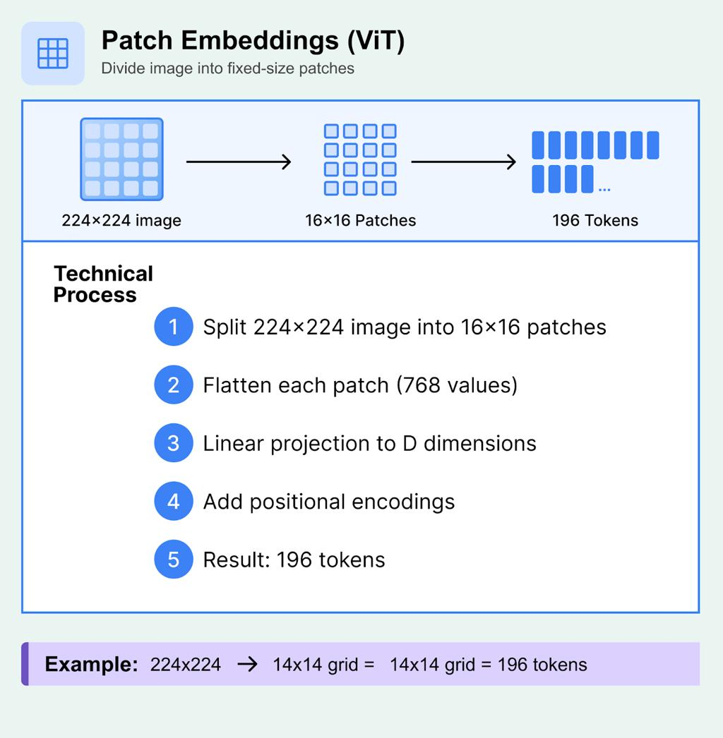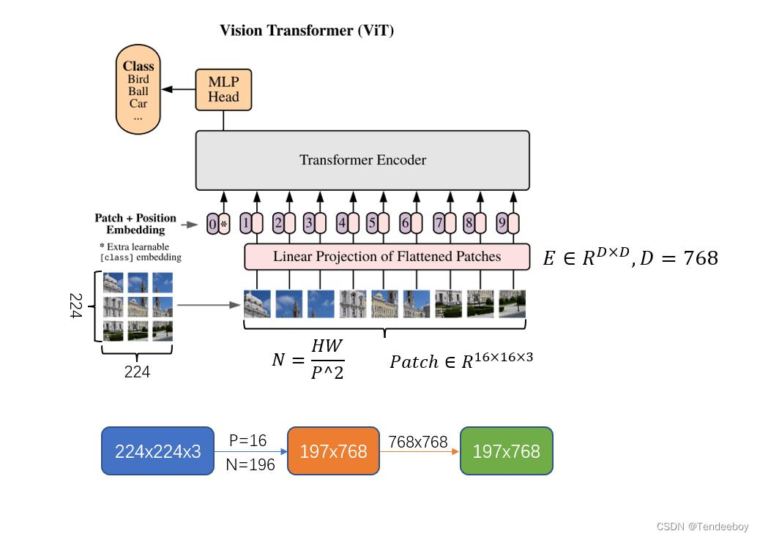

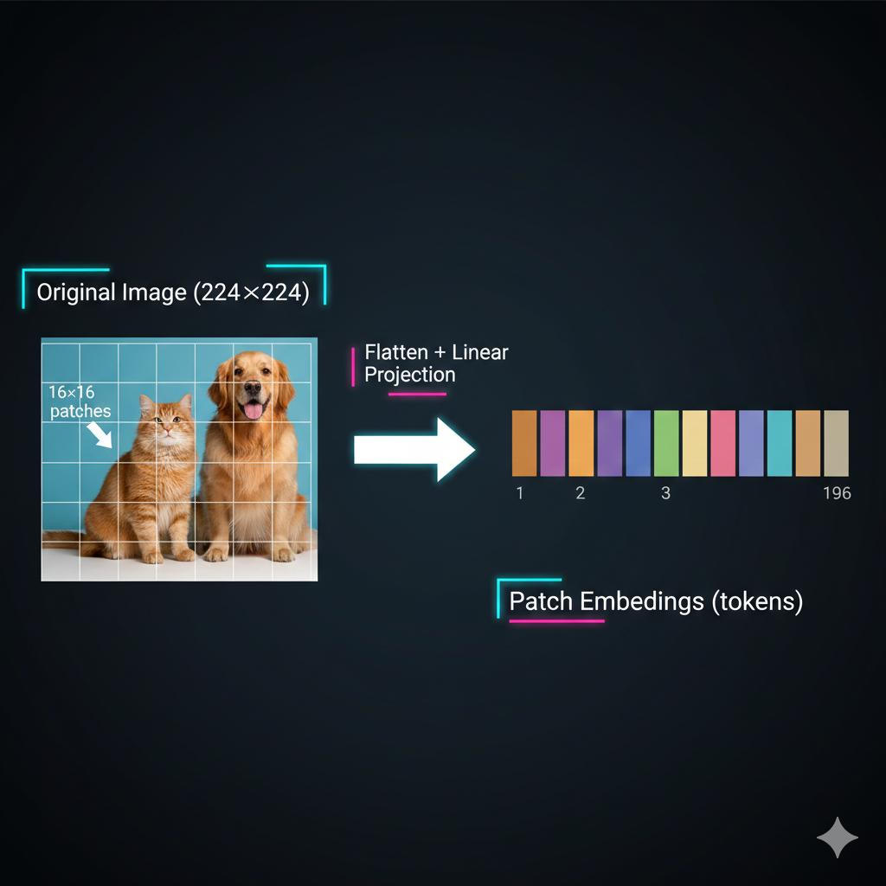
4.5 Patch Embedding
Patch embedding is an important step in Vision Transformer-based image processing, where the input image is converted into a sequence of smaller image patches that can be processed by the transformer model. Initially, the preprocessed image is divided into several fixed-size, non-overlapping patches. Each patch contains a small portion of the original image and preserves important local visual information. The pixel values of each patch are then flattened into a one-dimensional vector. These flattened patch vectors are passed through a trainable linear projection layer to convert them into fixed-dimensional embedding vectors. Since transformers process sequential data, the resulting patch embeddings represent the image as a sequence of visual tokens. Positional information is also added to the embeddings so that the model can understand the original spatial position and relationship between different patches. The sequence of patch embeddings is then provided to the transformer encoder, where self-attention mechanisms learn relationships between different regions of the image. This allows the model to capture both local and global visual features effectively. Thus, patch embedding converts the raw image into a structured token representation that enables the transformer architecture to perform efficient image feature extraction and classification.
4.6 Transformer Encoder
The Transformer Encoder is the core component used to process the sequence of patch embeddings and extract meaningful visual features from the input image. The sequence of patch embeddings generated during the patch embedding stage is first provided to the encoder. The encoder uses a Multi-Head Self-Attention mechanism to identify relationships between different image patches and understand how one region of the image is related to other regions. Unlike conventional convolutional networks that mainly focus on local regions, self-attention allows the model to capture both local and global relationships across the entire image. The output of the self-attention layer is passed through a Feed Forward Neural Network (FFN) to further transform and refine the extracted features. Layer normalization and residual connections are used within the encoder to improve training stability and preserve important information from previous layers. Multiple transformer encoder layers can be stacked to learn increasingly complex representations from the image. Through this process, the encoder effectively captures important spatial and contextual information from different image patches. The final encoded representation is then passed to the classification stage, where the learned features are used to predict the appropriate class

4.7 Multi-Head Self-Attention
Multi-Head Self-Attention is a key mechanism in the Transformer Encoder that enables the model to understand the relationships and dependencies between different image patches. After the input image is divided into patches and converted into patch embeddings, each patch is represented as a token in a sequence. The self-attention mechanism generates three important representations called Query (Q), Key (K), and Value (V) from these patch embeddings. The Query and Key representations are compared to calculate attention scores, which determine how much importance should be given to each patch when processing another patch. The attention scores are then applied to the Value representations to produce a weighted representation containing relevant information from different parts of the image. In Multi-Head Self-Attention, multiple attention heads operate in parallel, allowing the model to focus on different types of relationships and visual features at the same time.
4.8 Shared Backbone
The shared backbone is an important component of the proposed deep learning architecture that is responsible for extracting common and meaningful features from the input images. In this approach, the same backbone network is shared across different tasks or branches of the model, allowing all branches to use a common feature representation instead of learning completely separate features. The preprocessed image is first passed through the patch embedding stage and then through the Transformer Encoder, where the backbone extracts important spatial, structural, and contextual information from the image. The shared features obtained from the backbone are then forwarded to the respective task-specific layers for further processing and prediction. Sharing the backbone reduces the number of trainable parameters, decreases computational requirements, and avoids unnecessary duplication of feature extraction operations. It also helps the model learn generalized visual representations that can be useful across different classification or prediction tasks. During training, the backbone learns from the combined information received from the different branches, which can improve feature quality and overall model performance. Thus, the shared backbone provides an efficient and unified feature extraction mechanism while allowing the individual branches to perform their specific tasks effectively.
4.9 Disease Classification Head
The Disease Classification Head is the final component of the proposed deep learning architecture responsible for identifying and classifying the disease present in the input image. The feature representation obtained from the shared backbone is provided as input to the classification head, where the extracted high-level features are further processed for disease prediction. The classification head generally consists of one or more fully connected layers that transform the learned feature representation into class-specific outputs. A suitable activation function, such as Softmax, is used in the final layer to generate probability values for each disease category. The class with the highest probability is selected as the predicted disease. During training, the predicted output is compared with the actual class label using an appropriate loss function, and the model parameters are updated through backpropagation to reduce the classification error. The classification head enables the system to distinguish between different disease categories based on the visual patterns learned from the input images. It provides the final prediction that can be used for automated disease identification and decision support. Therefore, the Disease Classification Head converts the extracted deep features into meaningful disease classifications and plays a crucial role in achieving accurate and reliable prediction.
4.10 Severity Classification Head
The Severity Classification Head is the component of the proposed deep learning architecture responsible for determining the severity level of the identified disease. The high-level feature representation obtained from the shared backbone is passed to the severity classification head, where the learned features are analyzed to identify the extent or stage of the disease. The classification head consists of fully connected layers that transform the extracted feature representation into severity-specific outputs. Depending on the number of severity categories, the final layer produces probability scores for each level, such as mild, moderate, and severe. A Softmax activation function can be used in the final layer to obtain the probability of each severity category, and the category with the highest probability is selected as the final prediction. During training, the predicted severity level is compared with the actual severity label using an appropriate classification loss, and the network weights are updated through backpropagation. This enables the model to learn visual patterns associated with different levels of disease severity. The severity classification head works together with the disease classification head, allowing the system to not only identify the disease but also estimate its severity. Therefore, this component provides additional information about the condition of the affected area and supports more detailed and effective disease assessment.

5. DATASET AND EXPERIMENTAL SETUP
5.1 Dataset
The researchers developed a custom dataset containing:
3,345 rice-leaf images
The dataset contains:
10 disease types
and:
3 severity levels
- Mild
- Moderate
- Severe
Images were collected from agricultural regions in Punjab and West Bengal.
Images were captured using:
- DSLR camera
- Realme XT smartphone
This introduces realistic variation in:
- Lighting
- Background
- Camera quality
- Viewing angle
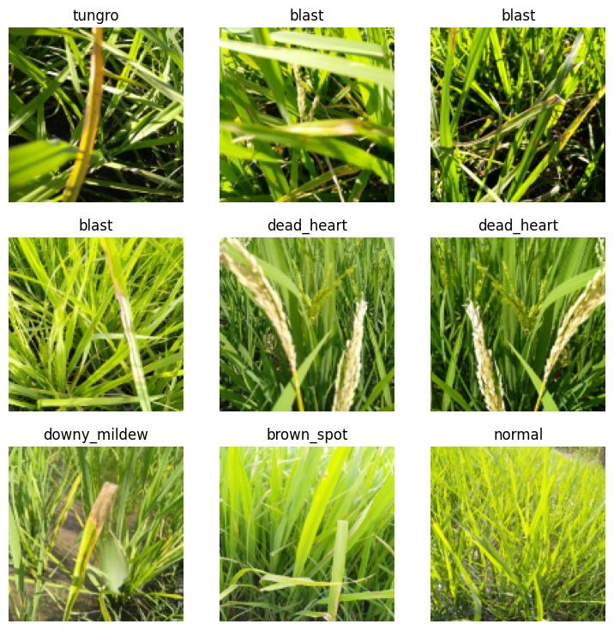
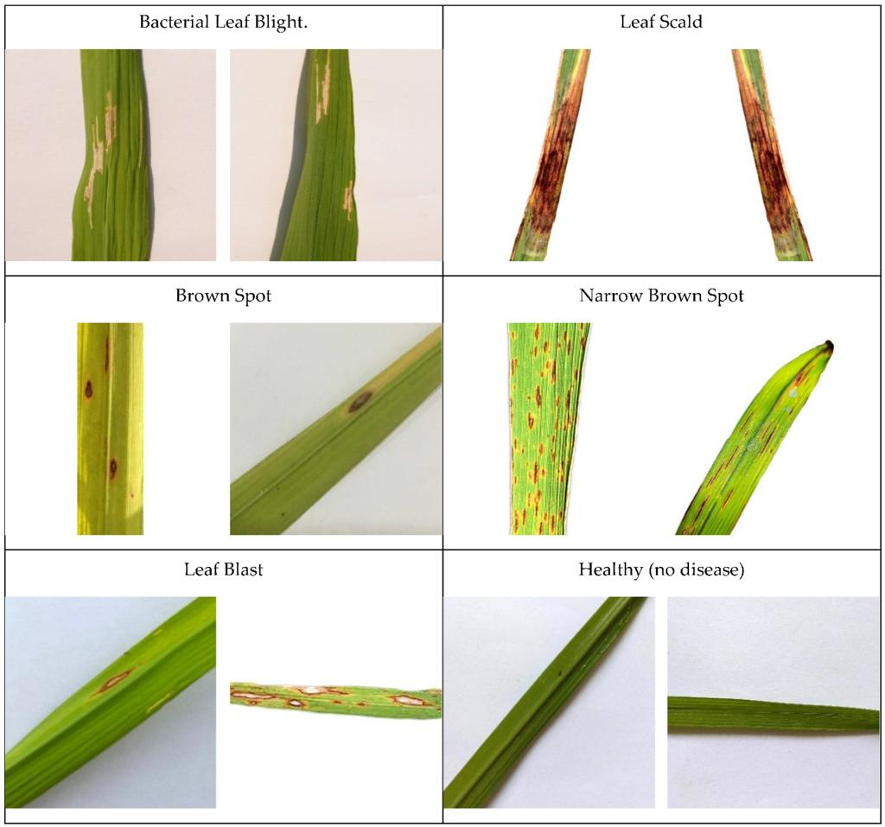
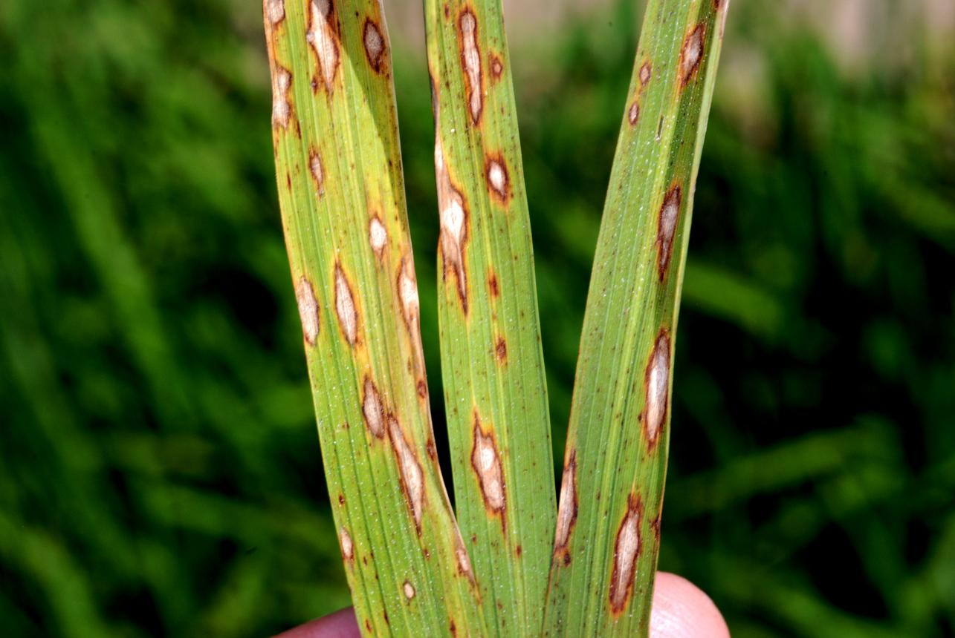

5.2 Dataset Split
Dataset | Number of Images | Percentage
Training | 2,676 | 80%
Testing | 669 | 20%
Total | 3,345 | 100%

5.3 Training Configuration
Parameter | Value
Optimizer | Adam
Learning Rate | 0.001
Batch Size | 32
Loss Function | Cross-Entropy
Dropout | 0.2
Epochs | 20
Augmentation | Rotation, Flipping, Brightness

5.4 Evaluation Metrics
The performance of the proposed deep learning model is evaluated using several standard evaluation metrics to measure its effectiveness in disease and severity classification. Accuracy is used to determine the overall percentage of correctly classified images out of the total number of test images. Precision measures how accurately the model identifies positive predictions by calculating the proportion of correctly predicted positive samples among all samples predicted as positive. Recall, also known as sensitivity, measures the ability of the model to correctly identify all actual positive cases. F1-score provides a balanced measure between precision and recall by calculating their harmonic mean. A confusion matrix is also used to analyze the classification results by showing the number of correctly and incorrectly classified samples for each disease or severity category. For severity classification, these metrics help determine how effectively the model distinguishes between different severity levels such as mild, moderate, and severe. In addition, training and validation loss and accuracy can be monitored to evaluate the learning behavior of the model and identify issues such as overfitting or underfitting. These evaluation metrics provide a comprehensive assessment of the proposed system and help determine its reliability, accuracy, and generalization capability on unseen images.

6. RESULTS AND COMPARATIVE ANALYSIS
6.1 Disease Classification Results
Metric | Result
Macro F1-score | 53.52%
Micro F1-score | 53.63%
Weighted F1-score | 54.17%
AUC-ROC | 0.86
The highest disease-classification F1-score was achieved by Yellow Molte: 65.85%.
The lowest was Rice Blast: 48.64%.
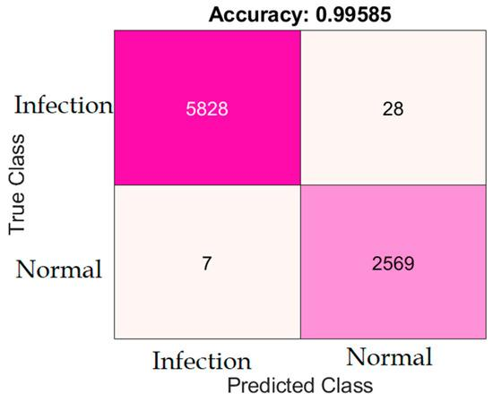
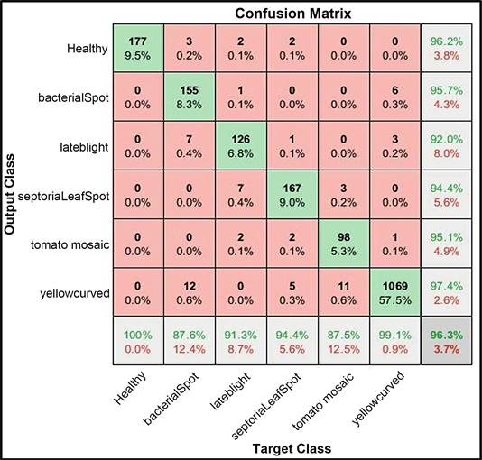
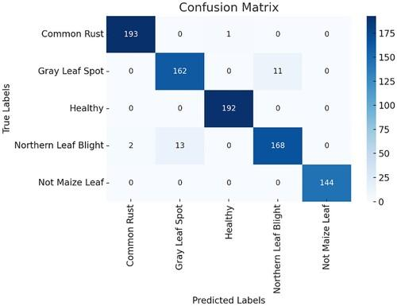
6.2 Severity Classification Results
Severity Class | F1-score
Mild | 81.70%
Moderate | 75.72%
Severe | 75.94%
Macro Average | 77.79%
Weighted Average | 77.94%

6.3 Comparative Analysis
The results can be summarized as:
Task | Weighted F1
Disease Classification | 54.17%
Severity Classification | 77.94%
The model performs considerably better in severity classification.The reason may be that disease classification involves distinguishing between 10 different disease classes, some of which have similar visual symptoms.Severity classification has only three classes, making the classification problem comparatively simpler.

7. STRENGTHS AND LIMITATIONS
7.1 Strengths
The proposed deep learning-based system has several strengths that make it effective for automated disease and severity classification. The use of Transformer Encoder and Multi-Head Self-Attention enables the model to capture both local and global relationships between different regions of an image. The patch embedding mechanism converts the input image into meaningful visual tokens, allowing the transformer to process image information efficiently. The use of a shared backbone provides a common feature representation for both disease and severity classification, reducing redundant computation and the number of trainable parameters. The separate Disease Classification Head and Severity Classification Head allow the system to perform both disease identification and severity assessment within a single architecture. Data augmentation improves the robustness of the model by providing different variations of training images and reducing overfitting. The system can also achieve consistent and automated predictions compared with manual image analysis. Furthermore, the use of evaluation metrics such as accuracy, precision, recall, F1-score, and confusion matrix provides a comprehensive assessment of the model's performance. Overall, the combination of transformer-based feature extraction and multi-task classification makes the proposed system efficient, scalable, and suitable for automated image-based disease analysis.
7.2 Limitations
1. Moderate Disease Classification
The weighted F1-score of 54.17% indicates that disease classification still requires improvement.
2. Similar Disease Appearance
Some diseases have visually similar symptoms.
3. Rice Blast Performance
Rice Blast achieved only 48.64% F1-score, demonstrating difficulty with certain disease categories.
4. Dataset Size
A larger and more diverse dataset could improve generalization.
5. Computational Requirements
Vision Transformers can require significant computational resources, especially during training.
6. Real-World Deployment
Additional testing would be required before deploying the model as a fully automated agricultural diagnostic system.

8. PROPOSED IMPROVEMENTS / FUTURE SCOPE
8.1 Hybrid CNN + Vision Transformer
The Hybrid CNN + Vision Transformer (ViT) approach combines the strengths of Convolutional Neural Networks (CNNs) and Vision Transformers to achieve effective image feature extraction and classification. In this architecture, the CNN component is initially used to extract important local features, such as edges, textures, shapes, and small visual patterns from the input image. The extracted feature maps are then converted into suitable patch or token representations and passed to the Vision Transformer. The Transformer uses Multi-Head Self-Attention to learn relationships between different image regions and capture global contextual information that may not be effectively represented by CNN layers alone. By combining local feature extraction from CNN with global feature modeling from the Vision Transformer, the hybrid architecture can provide a richer representation of the input image. This approach can improve the model's ability to distinguish between visually similar disease categories and identify important variations associated with disease severity. The extracted combined features are finally passed to the disease and severity classification heads to generate the required predictions. Thus, the Hybrid CNN + Vision Transformer architecture provides a balanced approach that benefits from the strong local pattern recognition capability of CNNs and the global dependency modeling capability of Vision Transformers.
8.2 Larger Dataset
Using a larger and more diverse dataset is an important future improvement for increasing the reliability and generalization capability of the proposed deep learning system. A larger dataset can contain images collected from different sources, environments, lighting conditions, image qualities, disease stages, and patient variations. Training the model with a greater number of diverse samples enables it to learn a wider range of visual patterns and reduces the possibility of overfitting to a limited set of images. The dataset can also include a balanced number of samples for each disease category and severity level, such as mild, moderate, and severe, to prevent classification bias toward frequently occurring classes. Additional images can be obtained from publicly available medical datasets and properly verified sources while maintaining appropriate data quality and labeling standards. Data augmentation can further increase the diversity of the training samples by generating variations of the original images. A larger dataset can therefore help the Transformer-based model learn more robust features through the shared backbone and improve the performance of both the disease classification and severity classification heads. Ultimately, expanding the dataset can lead to better accuracy, improved generalization on unseen images, and more reliable performance in real-world applications.
8.3 Lightweight Model
A lightweight Transformer could be developed for:
- Smartphones
- Drones
- Edge devices
- Low-power agricultural systems
8.4 Explainable AI
Explainable AI can be used to show the specific leaf regions responsible for a prediction.
For example:
Rice Leaf
↓
AI Model
↓
Highlighted Disease Region
↓
Disease Prediction
This would make the system easier for farmers and agricultural experts to understand and trust.

9. PRACTICAL INDUSTRY APPLICATION
The reviewed method can be applied to precision agriculture and smart farming.
9.1 Smartphone Application
A farmer can take a picture of a rice leaf using a smartphone.
Rice Leaf Photo
↓
Mobile Application
↓
Vision Transformer
↓
Disease Detection
↓
Severity Estimation
↓
Farmer Alert
The application could display:
Disease: Rice Blast
Severity: Moderate
Confidence: Model-generated score
9.2 Drone-Based Monitoring
Agricultural drones can capture images of large rice fields.
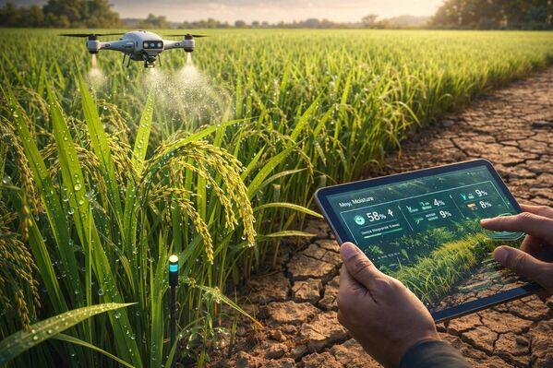
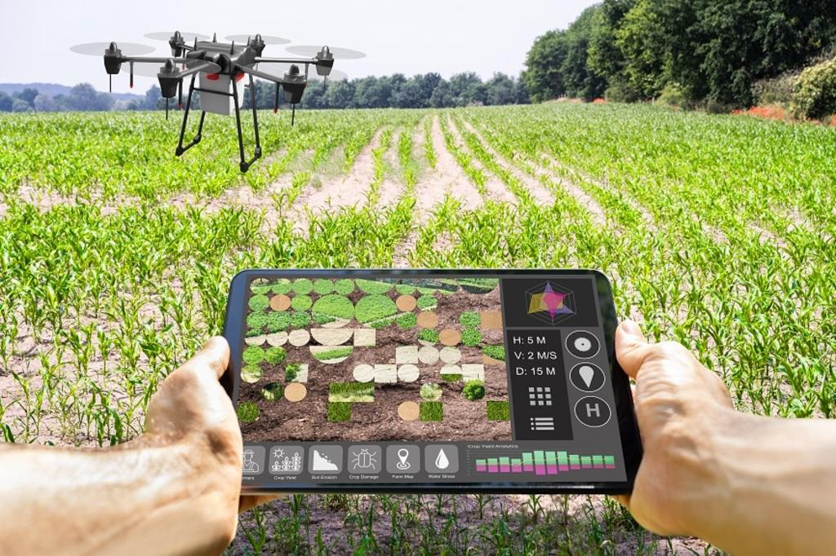
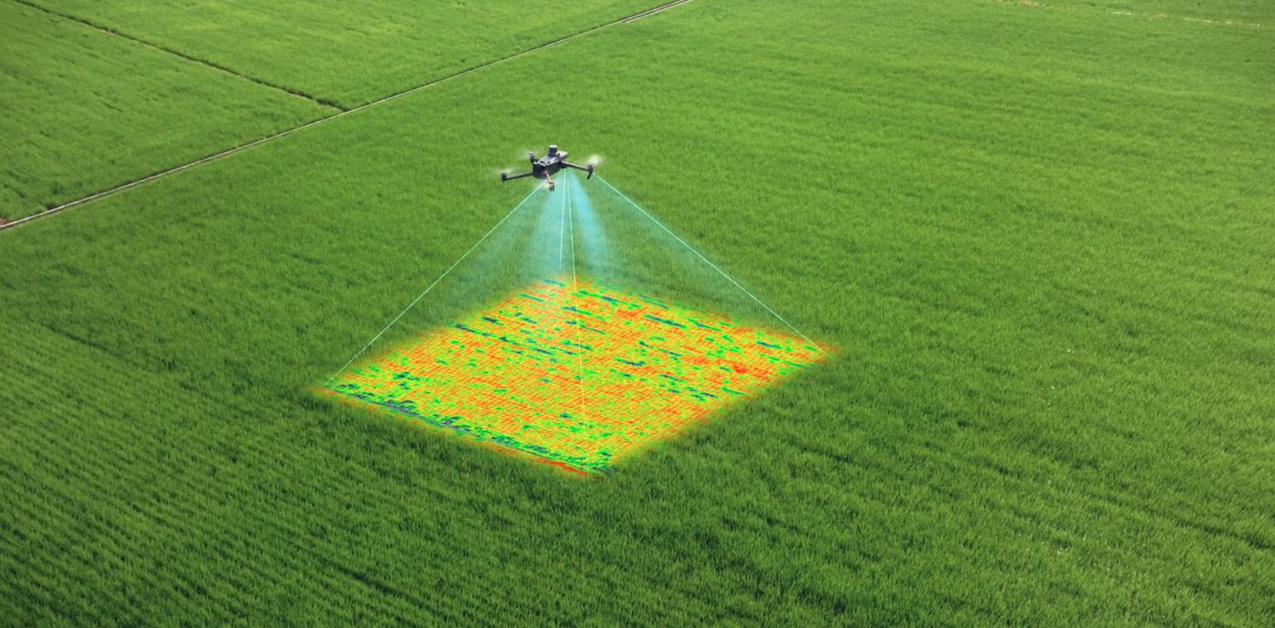
The AI system can analyze the captured images and identify areas showing disease symptoms.
This would be particularly useful for large farms where manual inspection is difficult.
9.3 Smart Farming Platform
The proposed system can be further developed into a Smart Farming Platform that integrates artificial intelligence, image processing, and IoT technologies to support efficient crop monitoring and disease management. The platform can allow farmers to capture crop images using smartphones, cameras, drones, or other field-monitoring devices and upload them to the system for analysis. The collected images are first preprocessed and enhanced before being passed to the trained deep learning model. The model uses the shared backbone to extract important visual features and the classification heads to identify the possible crop disease and determine its severity level. Based on the prediction, the platform can provide farmers with useful information about the affected crop and recommend appropriate actions, such as monitoring, treatment, or removal of severely affected plants. IoT sensors can also be integrated to collect environmental information such as soil moisture, temperature, humidity, and rainfall, which can provide additional context for disease monitoring. The platform can maintain historical records and generate reports to help farmers track crop health over time. By combining image-based disease detection with real-time field data, the Smart Farming Platform can support early disease identification, reduce unnecessary pesticide usage, minimize crop losses, and improve overall farm productivity. Thus, the proposed system can be extended into an intelligent and user-friendly agricultural platform for efficient and sustainable crop management.

10. CONCLUSION AND REFERENCES
10.1 Overall Evaluation
The selected article presents a meaningful application of Vision Transformers in precision agriculture.Its major contribution is the development of a system capable of performing two tasks:Disease identification + Disease severity estimationThe use of a shared backbone and separate classification heads is an effective design because common visual features can be reused for both tasks.The reported results show that the model performs better for severity classification than disease classification. The 77.94% weighted F1-score for severity classification demonstrates promising performance, while the 54.17% weighted F1-score for disease classification indicates that additional improvements are necessary.In my evaluation, the research is practically relevant and technically interesting, particularly because it applies an advanced deep learning architecture to a real agricultural problem.However, before the model can be used as a completely reliable commercial diagnostic system, it should be tested with larger and more diverse datasets and under more challenging field conditions.

10.2 Personal Evaluation
From my perspective, the most valuable aspect of the research is that it does not stop at identifying the disease. It also attempts to determine how severe the disease is.This makes the system more useful for real agricultural decision-making.I would improve the system by combining a CNN with a Vision Transformer. The CNN would extract local features such as spots and textures, while the Transformer would capture relationships between different areas of the leaf.I would also develop a lightweight version that could run on smartphones or edge devices, allowing farmers to use the system directly in the field.Therefore, the research provides a strong foundation for developing future AI-powered smart agriculture systems.
10.3 Final Conclusion
The research demonstrates the potential of Vision Transformers for automated rice disease detection and severity estimation.The complete system consists of:Image Acquisition → Preprocessing → Otsu Thresholding → Patch Embedding → Transformer Encoder → Shared Backbone → Disease & Severity Prediction
The study achieved:
- 54.17% weighted F1-score for disease classification
- 77.94% weighted F1-score for severity classification
- 0.86 AUC-ROC
Although disease classification remains challenging, the research provides a valuable foundation for future precision-agriculture applications.With improvements such as hybrid CNN-ViT architecture, larger datasets, lightweight models, drone integration and explainable AI, the system could become more accurate and suitable for real-world agricultural deployment.

REFERENCES
[1] Roy, P. S., & Kukreja, V. (2025). Vision Transformers for Rice Leaf Disease Detection and Severity Estimation: A Precision Agriculture Approach. Journal of the Saudi Society of Agricultural Sciences, 24, Article 3.
[2] Springer Nature. Vision Transformers for Rice Leaf Disease Detection and Severity Estimation: A Precision Agriculture Approach.
[3] Dosovitskiy, A., et al. (2021). An Image is Worth 16×16 Words: Transformers for Image Recognition at Scale. International Conference on Learning Representations (ICLR).

